Initial Project Proposal

Year: _2023_ Semester: _Spring__ Project Name: _”Rigged” Card Shuffler______

Creation Date: _September 30, 2022__ Last Modified: Nov 4, 2022

Team Members (#1 is Team Leader):

Member 1: __Zachary Williams______________ Email: __will2051@purdue.edu________

Member 2: __Brian Lee____________________ Email: __lee3174@purdue.edu_________

Member 3: __Dan Gue_____________________ Email: __dgue@purdue.edu___________

Member 4: __Utkarsh Priyam_______________ Email: __upriyam@purdue.edu________

1.0 Description of Problem:

Card games are very commonly played in many people’s households, however, many games require varied dealing methods and deck sizes. Oftentimes, there are many players who, while they know how to play a certain game, do not know how to shuffle or deal the deck correctly for the game. While there are many products for shuffling decks, many are out of reach of the consumer because of price or policy and the ones that are available are extremely simplistic and very low quality. A higher quality, more affordable method of shuffling, dealing, and separating decks is desired.

2.0 Proposed Solution:

The team proposes a system for dealing a deck with the ability to deal into several variable size hands and has significant control over where each card ends up. We plan to use a web application hosted on the raspberry pi to give the user control to specify the ending conditions of the deck and the hands dealt. The system consists of a set of bins to hold the cards and methods of moving the cards between the bins. This may be a system of motors that move one card at a time or servos with levers that push larger chunks of cards between bins at a time. We plan to use image recognition (likely using a raspberry pi) to determine what each card is. Once the order of the cards is determined, we will use a microcontroller to control the motors/servos in order to shuffle the deck. Then, we will access the web app to determine the final deal and once again use the microcontroller to deal the cards into several stacks. The dealer will feature the ability to shuffle and deal the deck for several different card games as well as give the user control over where cards end up in the final deal.

3.0 ECE477 Course Requirements Satisfaction

3.1 Expected Microcontroller Responsibilities

Our microcontroller will be responsible for controlling the motors to move around the cards within the device and taking the pictures of cards for identification purposes. It will also be responsible for transferring information, likely via a wired or wireless protocol, to a separate processor for performing card recognition and algorithm execution. The onboard microcontroller will thus also be responsible for receiving the instructions via that same protocol. The microcontroller must also process and act on device inputs via an on-board user interface.

3.2 Expected Printed Circuit Responsibilities

For the proposed project we expect the PCB to incorporate at least a microcontroller, power supply, multiple motor control circuit, and regulation circuitry. Depending on how we progress through the class, other functionality may be added to the PCB.

4.0 Market Analysis:

There are two primary markets that we believe can be entered. The first is gatherings of families, friends, work colleagues, and other casual environments in which card games may be played, but not every player knows how to set up the game. Our device can greatly facilitate the game playing process by removing the uncertainty, human error, and human delay from the equation. In fact, according to the Toledo Blade, the United States Playing Card Company alone sells more than 100 million decks of playing cards every single year. Clearly, playing cards remain a key part of the entertainment toolbox for millions of people, and an inexpensive and easy to use device to expedite game night would likely be useful to a segment of these people. In addition, according to Grand View Research, the playing cards and board games market was valued at 11.95 billion dollars in 2018, and is projected to continue to grow. This fact leads us to believe that there is a growing population of card players, as well as a continued demand for products in the playing card adjacent market.

The second market is that of amateur “magicians” who are looking for a gimmicky way to create illusions for their friends, family, or colleagues. Because our device is planned to have immense precision in terms of the location of specific cards, it can be used to “rig” deals such that when given information about a game and the number of hands, a “winning” hand can be given to the user. We believe this market for gimmick illusions exists because of the existence of products like the “Magic Mixies Magical Misting Crystal Ball with Interactive 8 inch Pink Plush Toy and 80+ Sounds and Reactions,” which retail for nearly $80 while not providing much of a real illusion.

5.0 Competitive Analysis:

5.1 Preliminary Patent Analysis:

5.1.1 Card Shuffler and dealer (US20090166970)

This card shuffler is a manually activated and controlled mechanism for shuffling and distributing inserted cards into 2-4 hands for game play. Using gears, levers, and rotating disks, the shuffler reorders inserted cards one by one and outputs them into the desired number of stacks using a rotating platform.

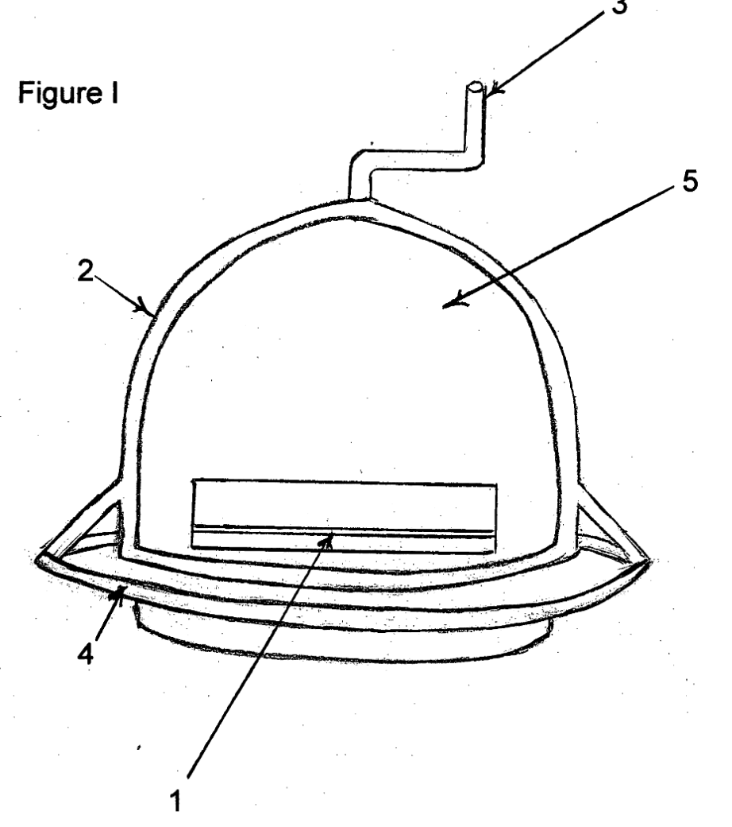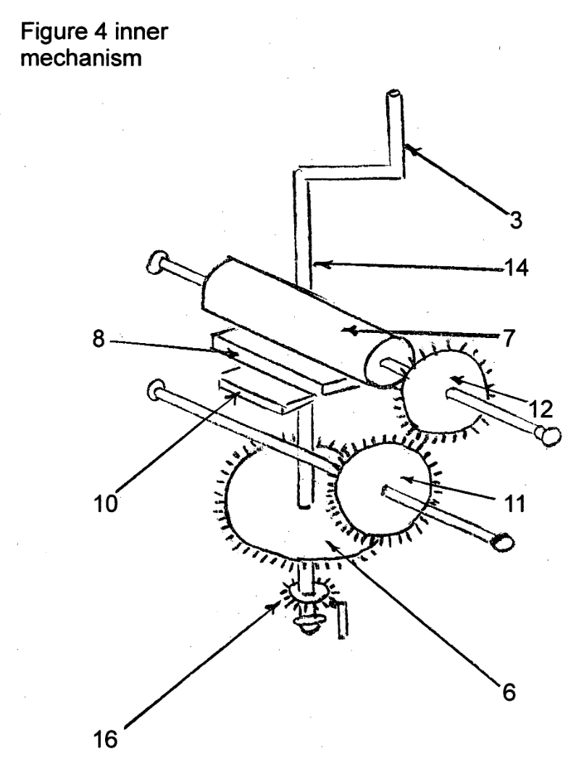

This patent is from 2009, but it is abandoned, so there should not be any infringement issues. Additionally, we can adapt the existing mechanism and power it with a motor instead of the hand crank, as the rest of the functions and mechanics closely align with our own goals.

5.1.2 Card dealer (CN201940009U)

This patent specifies a compact, easily portable card dealer that can take in cards and distribute a shuffled hand to any number of players using a rotating base mechanism. In practice, the mechanism is quite similar to the commercial product identified in Section 5.2.3. The mechanism uses a rotating base and a traction mechanism to shoot cards out of an opening in the dealer, and it can rapidly spin around to dispense cards around a table.

This patent is from 2011, but it expired in 2020, so there should not be any infringement issues. We can look into this patent’s proposed traction dispensing mechanism, as its ability to extract cards precisely one-by-one will be very useful in our own implementations.

5.1.3 Automatic card shuffler with pivotal card weight and divider gate (US8702101)

This patent specifies a hand-held card shuffling device that takes in a stack of cards, identifies them, and outputs them according to user specifications, which can include the number of stacks to form, excluding certain cards from dealing (i.e. special cards), or even how many cards should be in each hand. The proposed mechanism involves a traction mechanism to grab cards one-by-one and a rotating disk bank to collect the generated hands. Once all the hands are formed, they are dispensed in blocks from the rotating bank.

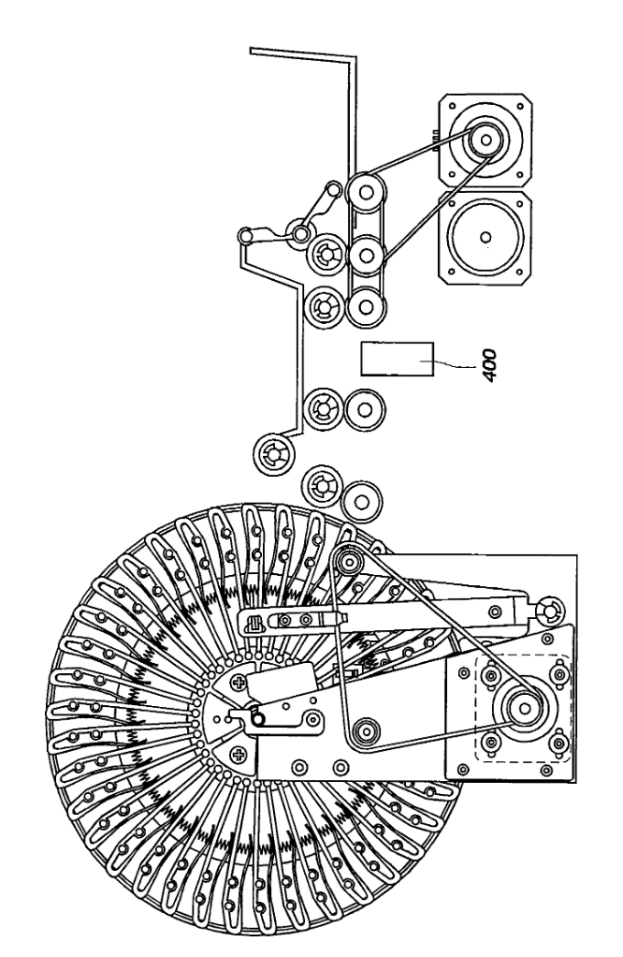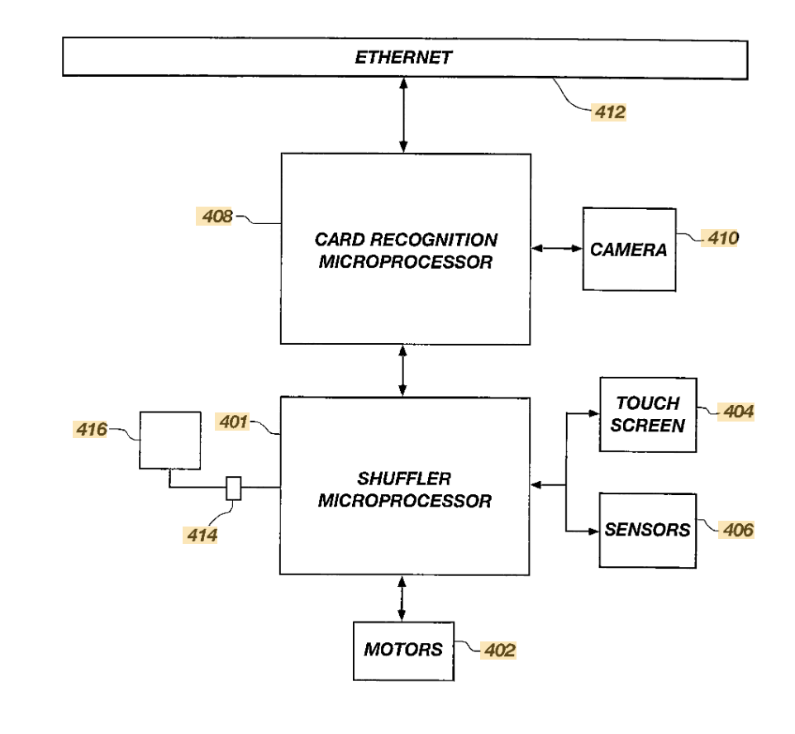

This patent is from 2014, with anticipated expiration in 2026. As a result, we cannot directly work with the proposed mechanism, particularly the large rotating bank that collects hands.

However, we should still be able to use other parts of their functional specification. In particular, their proposed mechanism uses cameras to identify the cards and sort/exclude them appropriately. We can use a similar approach of identifying cards and constructing our product architecture, as our problem statement closely aligns with that of this patent.

5.2 Commercial Product Analysis:

5.2.1 Family Card Shuffler #1:

This card shuffler is an easy and simple design. Running on four double A batteries, this design uses gears spun by motors in order to push the two piles on either side to the middle. This has a very predictable shuffle pattern and would not be able to give a true random shuffle.

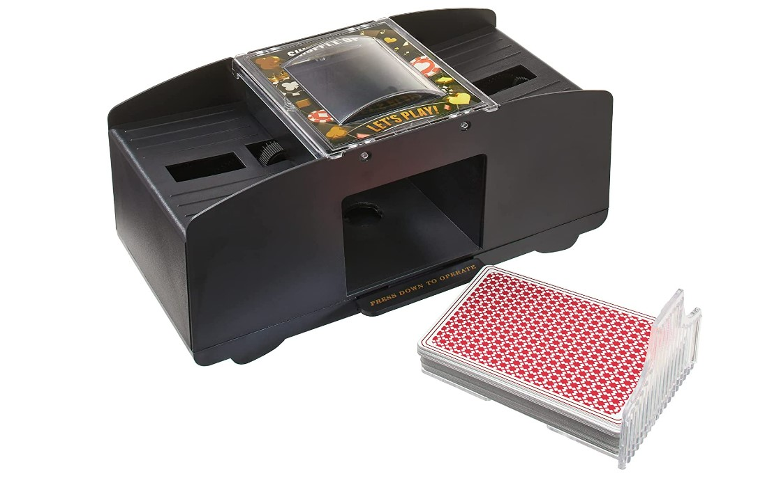

5.2.2 Casino Card shuffler#2:

Casino Card Shufflers are very sophisticated devices. They are built and constantly maintained to the highest standard to ensure a near perfect random deck is being dealt. Because of this finding specific schematics or description about how these machines work in detail is impossible. However, this blog by Casino World that was published in 2020 gives a rough description about how these machines work. By randomly placing cards onto shelves and then placing the cards back onto the main stack in a random order. This is most likely how our team will approach shuffling the cards especially since it gives us control on where cards should end up if the user chooses to do so.

5.2.3 Auto Dealer and Shuffler:

This product is most similar to what we wanted to design. This design has a working voltage between 100V-240V. This machine can deal a maximum of 8 decks (432 playing cards) and can deal different kinds of cards (paper, plastic, pvc). In addition to this the entire thing is customizable to deal with multiple different games. This means that the user can choose the number of cards dealt and how many different hands it needs to deal.

There is not a lot of technical information on this product on how it operates. However, we can assume that the top half rotates with a motor (most likely a stepper motor in order to have precise dealing) in order to distribute the cards into their correct pile. In addition to this we assume that a microcontroller is used in order to properly deal the cards based on the user’s wants.

This product is made by the company Underoof and they are based in China, though they ship globally.

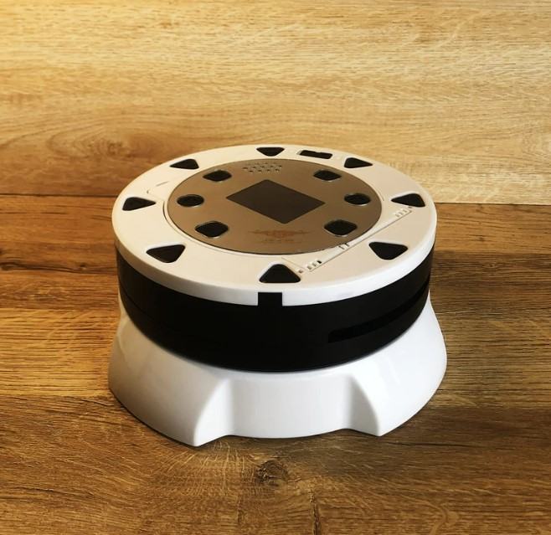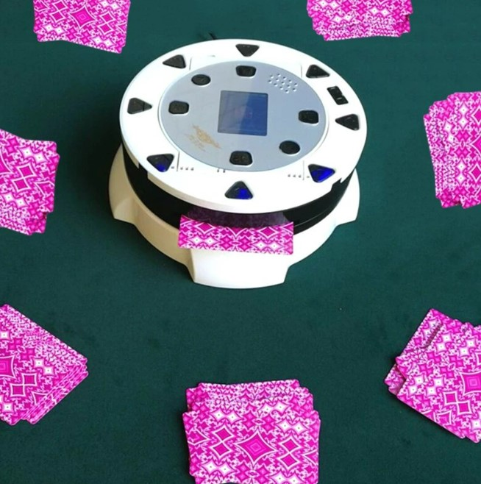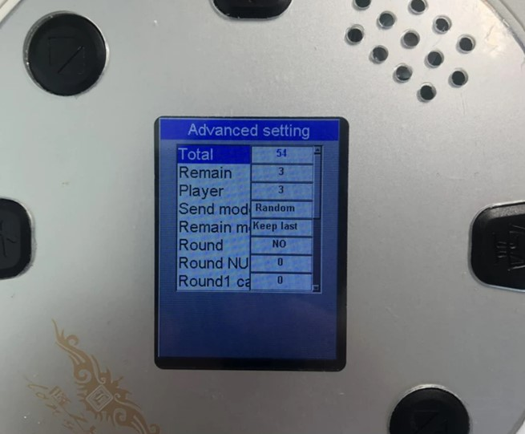

5.3 Open Source Project Analysis:

5.3.1 Axiomatic Card Dealing Robot:

This research paper covers the process of researching and creating a consistent and accurate card dealing mechanism. The project consists of research done by the team into customer needs, products already on the market, as well as the proposed solution to the product. The paper also includes documentation on the program flow, prototype created, and testing. The main takeaways from this project would be the mechanism that was used to deal the cards as well as the program flow used. These should be relatively easily adaptable to fit the needs of our product which will have a slightly different use for these overall. This project would be very similar to the mechanism that we plan to use for dealing the hands.

https://www.matec-conferences.org/articles/matecconf/pdf/2019/50/matecconf_icad2019_00010.pdf

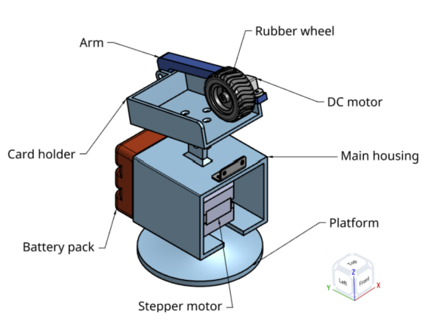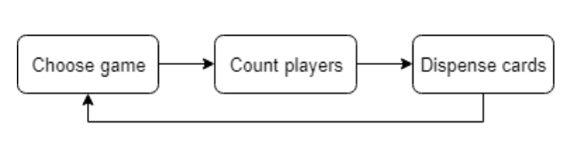

5.3.2 Rigged Card Sorting Machine:

This project is very similar to the mechanism that we plan to use for shuffling the cards. This project was able to achieve full accuracy for where cards end up in the final deck. This project uses a raspberry pi to control the whole system. This includes the motor movement for the actual movement of the cards, as well as the computer vision algorithm that determines what the next card is. The main takeaway from this project is the use of a mechanism to return cards back to the main deck. This should allow the problem of sorting the cards into any order solvable in any circumstance. For our project, we intend to use a similar mechanism for the same function. However, our project will differ in the use of the computer vision as well as the hardware used in the project. We plan to scan all of the cards and use computer vision to determine the initial order of the deck prior to starting shuffling. This should significantly reduce the complexity that is needed for our algorithm. We also plan to separately run the algorithm for card recognition and shuffling on an offboard processor and our main microprocessor respectively. This will hopefully increase the overall speed of the card recognition and shuffling algorithms compared to this project.

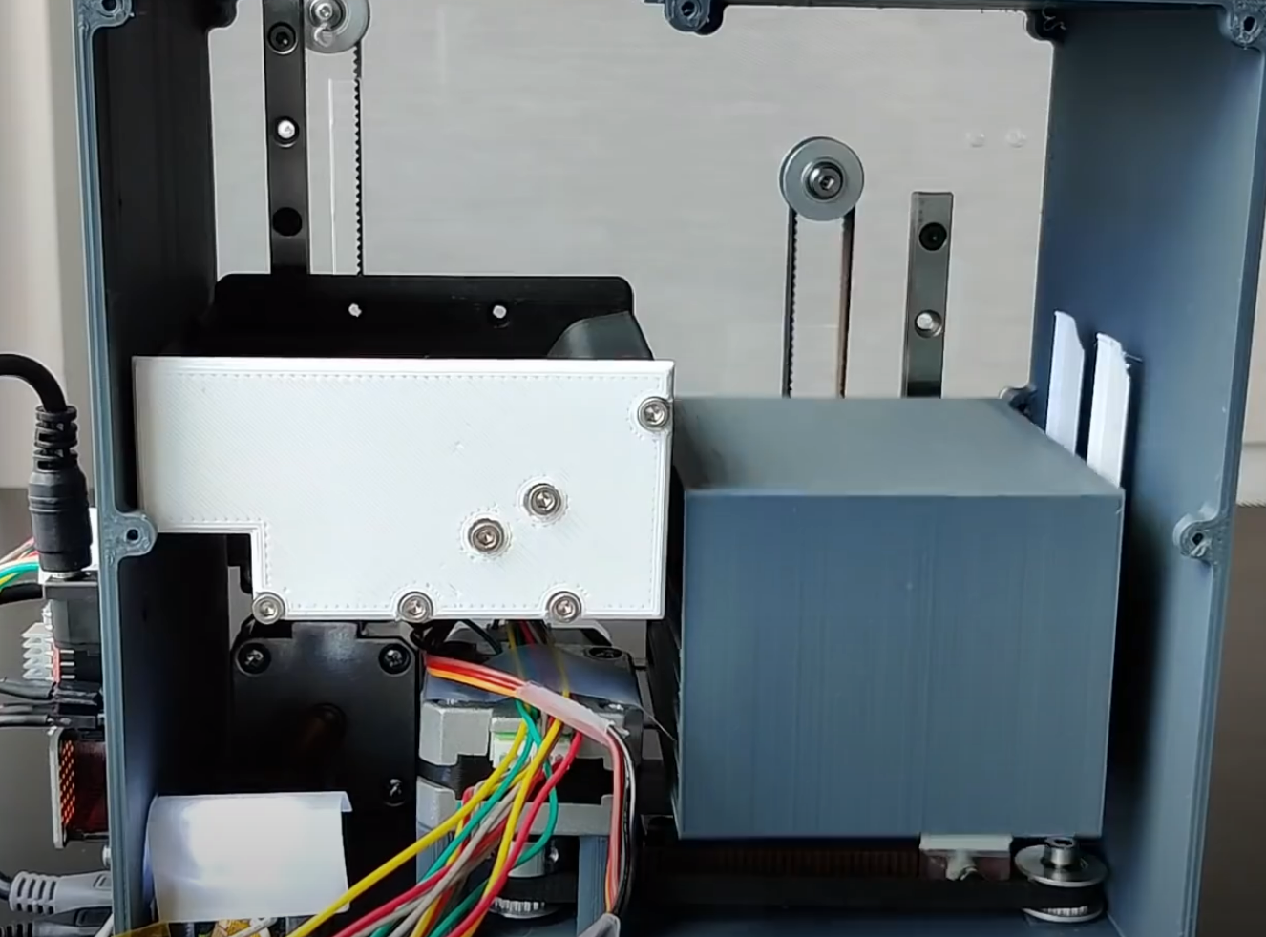

6.0 Sources Cited:

“247.32US $ 55% off: Underoof Smart playing card dealer machine customizable anti-cheating playing card Shuffler Tool for Home Casino Poker Game - Wedding Card Boxes - AliExpress,” *aliexpress.com*. [Online]. Available: https://www.aliexpress.us/item/3256804544841024.html. [Accessed: 04-Nov-2022].

3DprintedLife, “Rigged card sorting machine - always get the hand you want!,” *YouTube*, 18-Jul-2020. [Online]. Available: https://www.youtube.com/watch?v=eMTXyl7tPEk. [Accessed: 04-Nov-2022].

*888casino blog - you bet it's interesting*. [Online]. Available: https://www.888casino.com/blog/. [Accessed: 04-Nov-2022].

“Amazon.com : Cool chimpanzee automatic 2-deck card shuffler, home poker ...” [Online]. Available: https://www.amazon.com/Cool-Chimpanzee-Automatic-Shuffler-Blackjack/dp/B09YMWDM3Z. [Accessed: 04-Nov-2022].

“Amazon.com: Magic mixies magical misting crystal ball with interactive ...” [Online]. Available: https://www.amazon.com/Magic-Mixies-S2-Crystal-Ball/dp/B09Q4B7CZH. [Accessed: 04-Nov-2022].

“CN201940009U - card dealer,” *Google Patents*. [Online]. Available: https://patents.google.com/patent/CN201940009U/en. [Accessed: 04-Nov-2022].

“Playing cards & board games market size: Industry report, 2019-2025,” *Playing Cards & Board Games Market Size | Industry Report, 2019-2025*. [Online]. Available: https://www.grandviewresearch.com/industry-analysis/playing-cards-board-games-market. [Accessed: 04-Nov-2022].

Toledonews, “Playing cards have been game night go-to for thousands of years,” *The Blade*, 30-Mar-2020. [Online]. Available: https://www.toledoblade.com/a-e/living/2020/04/04/playing-cards-have-been-a-game-night-go-to-for-thousands-of-years/stories/20200405004. [Accessed: 04-Nov-2022].

“US20090166970A1 - Card Shuffler and dealer,” *Google Patents*. [Online]. Available: https://patents.google.com/patent/US20090166970. [Accessed: 04-Nov-2022].

“US8702101B2 - automatic card Shuffler with pivotal card weight and Divider Gate,” *Google Patents*. [Online]. Available: https://patents.google.com/patent/US8702101. [Accessed: 04-Nov-2022].

Appendix 1: Concept Sketch

Concept Overview

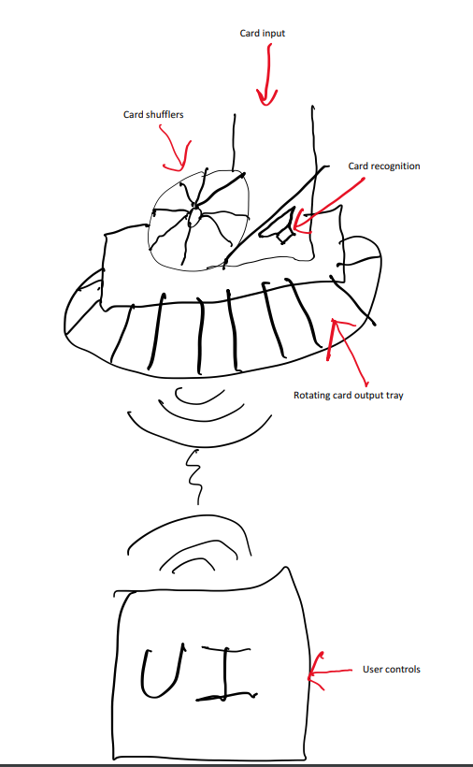

Functional Sketch

